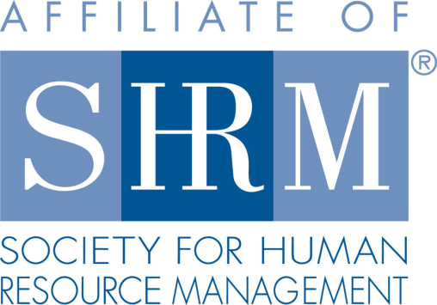
Federal Court Report
Part-Time Deputy Coroners Advance Overtime Claims
11/30/2021
By Allison R. Musante - Swerdlow Florence Sanchez Swerdlow & Wimmer
A member of Worklaw® Network
Part-time deputy coroners who were suing for overtime pay arguably did not fit within the Fair Labor Standards Act's (FLSA's) personal staff exemption, the 3rd U.S. Circuit Court of Appeals ruled, vacating summary judgment in a Pennsylvania county's favor.
Employees of state and local governments are usually protected by federal employment laws like the FLSA, which establishes a variety of protections that govern the wages an employee earns, such as minimum wage and overtime. That being said, there are employees who are exempt from the protections of the FLSA. Specifically, the FLSA excludes from its definition of covered employees those who work for a state, its political subdivision or an intergovernmental agency, who are not civil servants under relevant state laws, and who fall within one of many enumerated categories, including those selected by a public official to be a member of that official's personal staff. This exemption is called the personal staff exemption.
The three plaintiffs worked as part-time deputy coroners in Schuylkill County, Pa. They also each had other jobs for the county as well. The plaintiffs sued the county claiming that the county violated the FLSA by failing to pay them overtime and then terminating them in retaliation for seeking overtime pay. The trial court granted summary judgment in favor of the county, concluding that the plaintiffs each fell under the personal staff exemption to the FLSA because they were the personal staff of the county's elected coroner. The plaintiffs appealed.
The appellate court ruled, among other things, that granting summary judgment was not appropriate, as there were material factual disputes concerning whether the plaintiffs fell under the personal staff exemption to the FLSA.
In an issue of first impression for the 3rd Circuit, the appellate court concluded that two themes would be used to determine whether an employee fell under the personal staff exemption to the FLSA. For the first theme, in order for an employee to be considered the personal staff of an elected official, the employee must work closely and hold a sensitive position of trust and confidence. This means the official will often directly and immediately supervise the personal staff, there will be regular contact between them, and the personal staff will be trusted to handle confidential information and decisions.
For the second theme, the official must have personal control over the hiring, promotion, work conditions, discipline and termination of the employee. Thus, it must be determined that the official can and does exercise more control over their personal staff than in a typical supervisor/employee relationship, meaning the official has outright control over the working relationship with the personal staff member. The court also made clear that whereas both themes must be satisfied to apply the personal staff exemption, no one factor is dispositive as it is a very fact-specific analysis where context matters.
Based on its new two-part analysis, the court found there were disputed issues of fact as to whether the plaintiffs fell within the personal staff exemption, as it was unclear whether the plaintiffs worked closely enough with the coroner and whether the coroner exercised enough personal control over the plaintiffs. The 3rd Circuit therefore vacated the trial court's order granting summary judgment.
Clews v. County of Schuylkill, 3rd Cir., No. 20-2216 (Aug. 30, 2021), petition for en banc and panel rehearing denied (Sept. 29, 2021).
Professional Pointer: This case should be of interest to state and local governments whose officials maintain a personal staff. Determining whether the personal staff of an elected official is exempt from the protections of the FLSA is a very fact-specific analysis where it must be established that the employee works closely with the official in a sensitive position of trust and confidence and the official exercises personal control over the staff member. If an official's personal staff does not meet these requirements, then those employees will be protected by the provisions of the FLSA.
Allison R. Musante is an attorney with Swerdlow Florence Sanchez Swerdlow & Wimmer, the Worklaw® Network member firm in Beverly Hills, Calif.

