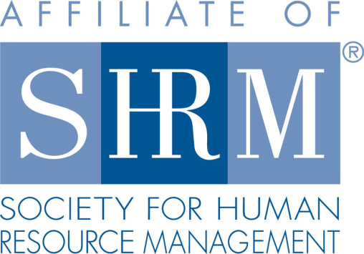
Federal Court Report
Employer’s Requests for Medical Records Complied with the ADA
4/19/2022
By Sean S. Kelly - Ross, Brittain & Schonberg Co. LPA
A member of Worklaw® Network
An employer's requests for medical records were job-related and consistent with business necessity under the Americans with Disabilities Act (ADA), the 4th U.S. Circuit Court of Appeals decided.
The plaintiff worked for Norfolk Southern Railway Company as a locomotive engineer for 18 years. Locomotive engineers are subject to Federal Railroad Administration regulations regarding drug and alcohol use.
In 2012, the plaintiff tested positive for amphetamines after a train he was operating derailed. He continued working but was subject to follow-up drug testing for five years. In 2016, he tested positive for amphetamines and codeine. He explained he was taking Adderall for attention deficit/hyperactivity disorder (ADHD) and Tylenol No. 3 for a back condition, both by prescription.
Norfolk Southern requested that the plaintiff provide medical records relating to his medication usage within 30 days. The letter requested that his physicians address his diagnoses, the possible side effects of his medication, his ability to safely perform essential job functions, and any recommended work restrictions or accommodations.
Later that year, the plaintiff ruptured his Achilles tendon and took medical leave. Norfolk Southern again requested medical information about his injury so that it could determine his fitness for service as an engineer.
Norfolk Southern did not receive the plaintiff's medical records within either of the requested time frames. When it did receive medical records, they did not address much of the requested information. Norfolk Southern terminated the plaintiff's employment.
He appealed his termination to the Public Law Board and filed a complaint with the Equal Employment Opportunity Commission (EEOC), which determined that there was reasonable cause to believe that Norfolk Southern had violated the ADA. The plaintiff then filed suit in federal court, claiming that Norfolk Southern discriminated against him on the basis of disability by making improper medical requests and terminating him for failure to comply.
The district court granted summary judgment in favor of Norfolk Southern. The court concluded that Norfolk Southern had the right to request medical records because it had an objectively reasonable basis to believe that the plaintiff could not properly carry out his duties and that he posed a safety risk. The court also held that the plaintiff failed to demonstrate a prima facie case of discrimination because he did not show that he had a disability or that the employer's reasons for termination were pretextual.
In affirming judgment in favor of the employer, the court of appeals held that Norfolk Southern's medical requests were not only job-related but also federally required. The court noted that railroad operators are charged with a "very strict responsibility" of preventing damage and that the industry is "regulated pervasively to ensure safety." Norfolk Southern's medical requests were, therefore, consistent with business necessity under the ADA.
Coffey v. Norfolk Southern Railway Co., 4th Cir., No. 21-1248 (Jan. 14, 2022).
Takeaway: Employers should use caution when requesting an employee's medical records and make certain that the requests are job-related and consistent with business necessity.
Sean S. Kelly is an attorney with Ross, Brittain & Schonberg Co. LPA, the Worklaw® Network member firm in Cleveland.

